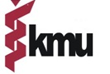
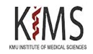
HOUSE JOB APPLICATION FOR KMU-IMS, KOHAT
Name of College/Institution
Public Sector/Private Sector
Name of Doctor
Father Name
CNIC No
Contact No
PM&DC Registration No
No of Attempts
Marks Obtained of all the Professionals/Total Marks

(10 Marks for each extra attempt in passing a professional exam, to be deducted from the obtained marks)
Adjusted Marks
Adjusted Percentage for merit

Note: Please attached following attested documents.
- PM&DC Certificate
- Attempt Certificate/Provisional Certificate/Character Certificate
- 5 Professionals DMC’s
- Domicile
- CNIC
- 02 passport size pictures.

Signature:
Dated: _____/____/2025

